LIMIT REFERENCE POINTS AND WILD SALMON POLICY RAPID STATUS SUMMARY:

2023 FRASER - EARLY STUART SOCKEYE STOCK MANAGEMENT UNIT

Executive Summary
There is 1 CUs in the Fraser – Early Stuart Sockeye SMU and it is designed as Red, placing this SMU below the LRP in terms of WSP rapid status (Figures 1-2 & Table 3).
The Takla-Trembleur-EStu CU was assessed as Red based on its recent generational average (8,014) being above 1,500, the absolute abundance metric can be used and the generational average is less than 10,000. The relative abundance metric can be used, however, the current dominant cycle generation average (47,357) is below the lower Relative-Abundance benchmark (97,682). It’s prior integrated status from 2015 was also Red.

Context
A key recommendation from a CSAS peer review process on Pacific Salmon Limit Reference Points (LRPs) is ‘CU [conservation-unit] status-based LRPs’ be used to meet the Fish Stocks provisions of the Fisheries Act (DFO 2022; Holt et al. 2023a, 2023b), which was supported nationally (DFO 2023). LRP's are assessed for Stock Management Units (SMUs), which can include one or more conservation units (CUs) (i.e., CUs are nested within SMUs). Using this approach, serious harm to a SMU is identified when any component CU zone drops into the Wild Salmon Policy (WSP) Red zone. Under this definition, the CU status-LRP is ‘100% of CUs with statuses above Red status’. The implications are that if a single CU is the Red status zone, the SMU is assessed as being below its LRP, which in turn triggers a DFO rebuilding plan for the SMU.

Forewords
Please fill in with perspectives or values that are not captured through the Rapid Status Assessment algorithm. Include whom the forewords should be attributed to (may be a group or individuals).

Data
The Fraser – Early Stuart Sockeye SMU is comprised of one cyclic CU with 26 streams that have individual NuSEDS population identifications that were used in the assessment (Table 1). The data used in this assessment were most recently described in detail in Grant et al. (2011), Grant & Pestal (2012), and Grant et al. (2020). The last integrated status assessment for these CUs occurred for return year 2015 (Grant et al. 2020). The data was also recently used in Huang et al. (2021) and Doutaz et al. (2023).
The primary forms of spawner enumeration surveys that occur across the CU in this SMU are visual survey expansions (peak live + cumulative dead), and some historical mark-recapture and fixed-site census (e.g. trap and fence). The timeseries for this CU starts in 1950, and for this assessment, ends with data from 2022.
Key steps in the data processing of this data set includes stream selection, gap infilling, and assessing data quality, which are described in detail in Grant et al. (2011). Streams were selected for inclusion in the assessment if they were surveyed for >70% of the historical time series. Missing stream-years were gap filled using cyclic-specific mean proportion approach, which leverages spatially proximate and correlated system’s abundance. Data quality is assessed based on the number and completeness of surveys, coverage of the spawning period, visibility and reliability records, and methodology. The average spawner data quality of Takla-Trembleur-Estu CU is considered “very good” (Grant et al. 2020) and is treated as absolute abundance that can be used in the absolute abundance and relative abundance-based benchmarks metrics.
Relative Abundance Benchmarks:
Relative abundance-based benchmarks for this CU were developed using a Larkin Stock-Recruit model due to it’s cyclic nature (Grant et al. 2020). Benchmarks for each cycle line (one dominant and three weak cycles) were last updated using brood years 1950-2010 (Grant et al. 2020). The 50th percentile of cyclic Larkin-based benchmarks are presented for each cycle line and are compared to the most recent ETS abundance from each respective cycle line (Table 2). In mimicking the integrated status approach and results, only the dominant cycle brood line is assessed against it’s relative abundance-based benchmark; which then stands as that metric’s result for the subsequent three cycle line’s years. E.g. The most recent dominant cycle line year for Takla-Trembleur-Estu is 2021. The comparison of the 2021 effective total spawner abundance is compared against it’s dominant cycle specific relative abundance benchmark. The result of this comparison is then used for return years 2021-2024 until the next dominant cycle return in 2025.
Table 1. Conservation Units (CUs) included in this Stock Management Unit (SMU) and lists of the streams/populations within each CU used in the Rapid Status Assessment. Streams have their NuSEDS population identifications in brackets.
CU No# | CU Name | Streams (Population ID)
SEL-06-13 | Takla-Trembleur-Estu | 15 Mile Creek (45590)  25 Mile Creek (45587)  Ankwill Creek (45596)  Bivouac Creek (45574)  Blackwater Creek (45600)  Consolidated Creek (45604)  Crow Creek (45583)  Driftwood River (45598)  Dust Creek (45581)  Forfar Creek (45571)  Frypan Creek (45593)  Gluske Creek (45572)  Kastberg Creek (45605)  Kotsine River (45603)  Lion Creek (45601)  Narrows Creek (45586)  O'Ne-ell Creek (45570)  Paula Creek (45557)  Point Creek (45585)  Porter Creek (45602)  Sakeniche River (45577)  Sandpoint Creek (45576)  Shale Creek (45588)  Sinta Creek (45580)  Sidney Creek (45558)  Van Decar Creek (45569)

Table 2. Relative abundance-based benchmarks and credible intervals by Conservation Unit (CU) and Cycle Line. Values were estimated in Grant et al. (2020). *Denotes the Dominant Cycle Line, which is used in the Rapid Status Assessment. Upper Benchmarks are multiplied by 1.1 in the algorithm.
CU Name | Cycle Line Recent Year | Benchmark | p50 | Credible Interval (p10-p90)
Takla-Trembleur-Estu | 2021* | 80% S_{MSY} | 376,174 | 222,946 – 711,337
Takla-Trembleur-Estu | 2021* | S_{gen} | 97,682 | 53,246 – 199,513

WSP Rapid Status Summary
Stock Management Unit (SMU) Limit Reference Point (LRP) status and narrative based on expert consensus
There are 1 CUs in the Fraser – Early Stuart Sockeye SMU and they are designed as Red, placing this SMU below the LRP in terms of WSP rapid status (Figures 1-2 & Table 3).
The background description of the Takla-Trembleur-Estu CU from the 2017 (Grant et al. 2020) assessment remains appropriate: “Abundances of this CU were particularly low from 1962-1968, peaked in the 1990s, and have subsequently decreased. Declining abundances are largely attributed to this CU’s long migration route (longest upstream migration of all Fraser Sockeye CUs), their spring/early summer upstream migration timing (May-July), and increases in water temperatures in the Fraser during their upstream migration (Grant et al. 2011).”
The dominant cycle of Takla-Trembleur-Estu has been variable through time, primarily shifting above and below the lower relative-abundance benchmark. Only the highest spawner abundance in the timeseries, 1993, was above the upper relative-abundance benchmark; after which, abundance has declined and remained below the lower relative-abundance benchmark since 2009.
The prior 2015 Integrated Status was Red. There was no change in status in the 2023 Rapid Status, which is Red with High Confidence.
A research priority that was identified during the expert review process ,which included Fraser and Interior Area DFO staff as well as First Nations representatives, was whether Early Stuart Sockeye should still be considered cyclic given the reduction in abundance on the dominant cycle line. Additionally, First Nations noted that although the WSP rapid status only focusses on abundance benchmarks relative to the dominant cycle line for cyclic stocks that First Nations also care about abundance trends on the off cycle years.
Reference the list of meetings and contributors can be found in Appendix 2
Future work: Future work should consider assessing under what circumstances a stock should be considered cyclic. Quantitative analyses should be undertaken to analyze how the difference in magnitude of escapement leads to cyclicity and when cyclicity should be considered in benchmark development or not.
The cyclical nature of Early Stuart may be changing. The dominant cycle has become very suppressed and is comparable to some of the abundances in the current “non-dominant” cycle lines. Without the strong density-dependent effects of a high abundance dominant cycle line, this CU may lose or change its cyclic nature. Future work is likely required in assessing the relative-abundance based benchmarks and how they are assessed against the CU.
Table 3. Wild Salmon Policy (WSP) Rapid Statuses for 2022. For background, refer to Appendix 1.
CU # | CU Name | WSP Rapid Status (2022) | WSP Rapid Status Node and Pathway
SEL-06-13 | Takla-Trembleur-Estu | RED,  HIGH | The recent year’s status (2023) is designated Red with High confidence based on the algorithm. The data could be assessed as Absolute Abundance and a Relative Abundance Metric was assessed against the dominant cycle line. The recent generational geometric-average is 8,014, which is greater than the 1,500 Absolute Abundance threshold, absolute abundance metric can be used and the current generation is less than 10,000. The relative abundance metric can be used and the current dominant cycle generational average (47,357) is less than the relative abundance benchmark of 97,682. (Figure 1 and 2; Table 4). This Red status has been consistent throughout the status time series from 2009 to 2022 (Figure 1). The 2023 WSP rapid status of Red matches the WSP integrated status from 2015 (Grant et al. 2020). Although not used to assess status for this CU, the Long-Term Trend and Percent Change Metrics also both indicate that the CU has been in steady decline (Figure 1).

SEL-06-13 Takla-Trembleur-Estu

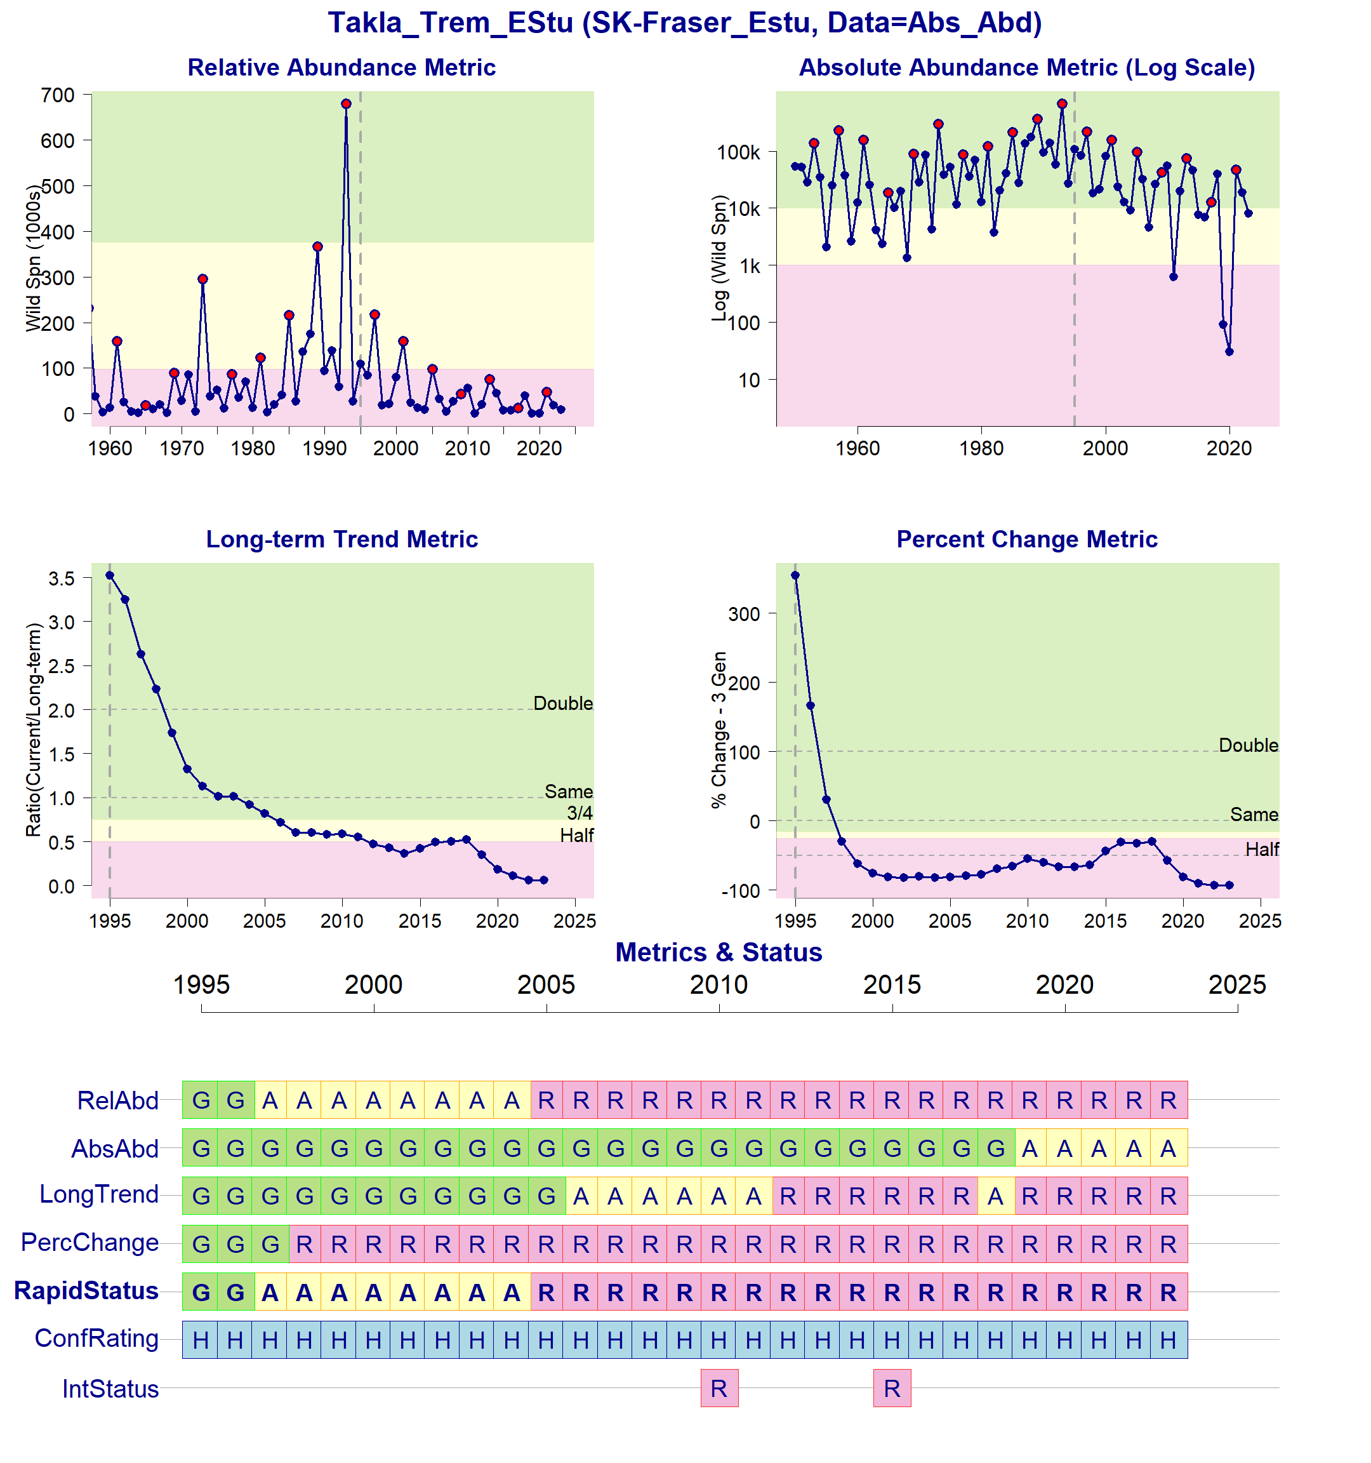Figure 1: Metrics and Status for Takla-Trembleur-Estu (SEL-06-13). Panels on top show the four standard WSP metrics, calculated based on the available time series of spawner abundances. Bottom panel summarizes the status for each individual metric and shows the resulting WSP rapid status for the CU with a confidence rating. If integrated WSP status assessments have been completed for this CU, they are shown on the last row (IntStatus). Note that metric benchmarks may differ from algorithm thresholds, since thresholds approximate the status determination process from past WSP integrated status assessments (see Figure 2).
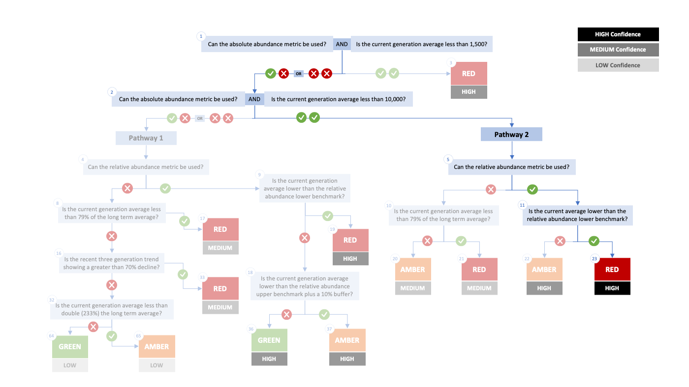

Figure 2. Algorithm pathway taken to assess status for the Takla-Trembleur-Estu (SEL-06-13) in 2023. The recent generational average is above the absolute abundance benchmark threshold of 1,500 (node 1), the absolute abundance metric can be used and the current generation average is less than 10,000 (node 2), the relative abundance metric can be used (node 5), but the current generation average is lower than the relative abundance lower benchmark. Status for this CU is therefore designated as Red with High confidence at Node 23.
Table 3: Decision tree path given data and metric values for the Takla-Trembleur-Estu (SEL-06-13) in 2023; this aligns with Figure 2 above. For each node, the algorithm decision is made by comparing the CUs current metric value to the metric threshold and answering Yes or No, running through sequential nodes and decisions until the final WSP rapid status for that CU and year is reached.
Node | Metric | Metric Threshold | CU’s Current Value | Decision
1 | Absolute Abundance | <1,500 | 8,014 | YES, NO
2 | Absolute Abundance | <10,000 | 8,014 | YES, YES
5 | Relative Abundance | Available? | 47,357 | YES
11 | Relative Abundance | < 97,682? | 47,357 | YES
23 | FINAL STATUS NODE |  |  | RED, HIGH

Cited and other Key References
Doutaz, D., Huang, A.-M., Decker, S., Vivian, T. 2023. Recovery Potential Assessment for Fraser River Sockeye Salmon (Oncorhynchus nerka), Nine Designatable Units Part 2: Biology, Habitat, Threats, Mitigations and Allowable Harm - Elements 1-11, 14, 16-18, 22. DFO Can. Sci. Advis. Sec. Res. Doc. 2023/003. xiii + 250 p.
DFO. 2005. Canada’s Policy for Conservation of Wild Pacific Salmon. Fisheries and Oceans Canada, Vancouver, B.C., pp. vi+ 49.
DFO. 2009. A Fishery Decision-Making Framework Incorporating the Precautionary Approach.
DFO. 2022. Methodologies and guidelines for defining limit reference points for Pacific Salmon. CSAS SAR 2022/030. pp. 16.
DFO. 2023. Science advice on guidance for limit reference points under the Fish Stocks provisions. DFO Can. Sci. Advis. Sec. Sci. Advis. Rep. 2023/009.
DFO 2024. Rapid status approximations for Pacific salmon derived from integrated status assessments under DFO’s Wild Salmon Policy. CSAS Sci. Resp. 2024/004.
Grant, S.C.H., MacDonald, B.L., Cone, T.E., Holt, C.A., Cass, A., Porszt, E.J., Hume, J.M.B., and Pon, L.B. 2011. Evaluation of Uncertainty in Fraser Sockeye (Oncorhynchus nerka) Wild Salmon Policy Status using Abundance and Trends in Abundance Metrics. Can. Sci. Advis. Sec. Res. Doc. 2011/087. Viii + 183
Grant, S.C.H. & G. Pestal. 2013. Integrated Biological Status Assessments Under the Wild Salmon Policy Using Standardized Metrics and Expert Judgement: Fraser River Sockeye Salmon (Oncorhynchus nerka) Case Studies. Can. Sci. Advis. Sec. Res. Doc. 2012/106. v + 132 p.
Grant, S.C.H., MacDonald, B.L., and Winston, M.L. 2019. State of the Canadian Pacific salmon: responses to changing climate and habitats. Can. Tech. Rep. Fish. Aquat. Sci. 3332: ix + 50 pp. Available from http://www.dfo-mpo.gc.ca/species-especes/publications/salmon-saumon/state-etat-2019/abstract-resume/index-eng.html
Grant, S.C.H., Holt, C., Pestal, G., MacDonald, B.L. 2020. The 2017 Fraser Sockeye Salmon (Oncorhynchus nerka) Integrated Biological Status Re-Assessments Under the Wild Salmon Policy Using Standardized Metrics and Expert Judgment. Can. Sci. Advis. Sec. Res. Doc. 2020/035. vii + 211 p.
Holt, C.A., Cass, A., Holtby, B., and Riddell, B. 2009. Indicators of status and benchmarks for Conservation Units in Canada’s Wild Salmon Policy. Can. Sci. Advis. Sec. Res. Doc. 2009/058: viii + 74.
Holt, C.A., Holt, K., Wor, C., Warkentin, L., Connors, B., Grant, S.C.H., and Huang, A.-M. 2023a. Guidelines for Defining Limit Reference Points for Pacific Salmon Stock Management Units. Can. Sci. Adv. Sec. Res. Doc. 2023/009: iv + 66.
Holt, K., Holt, C.A., Warkentin, L., Wor, C., Davis, B., Arbeider, M., Bokvist, J., Crowley, S., Grant, S.C.H., Luedke, W., McHugh, D., Picco, C., and Will, P. Van. 2023b. Case Study Applications of LRP Estimation Methods to Pacific Salmon Stock Management Units. Can. Sci. Advis. Sec. Res. Doc. 2023/010: iv + 129.
Holt, C.A., and Irvine, J.R. 2013. Distinguishing benchmarks of biological status from management reference points: a case study on Pacific salmon in Canada. Environ. Conserv. 40 (4): 345–355. doi:https://doi.org/10.1017/S0376892913000209
Holtby, B.L., and Ciruna, K.A. 2007. Conservation units for Pacific salmon under the Wild Salmon Policy. Can. Sci. Advis. Sec. Res. Doc. 2007/070: viii + 350 pp. Available from http://www.dfo-mpo.gc.ca/csas-sccs/publications/resdocs-docrech/2007/2007_070-eng.htm
Huang, A-M., Pestal, G., Guthrie, I. 2021. Recovery Potential Assessment for Fraser River Sockeye Salmon (Oncorhynchus nerka) – Nine Designatable Units: Probability of Achieving Recovery Targets - Elements 12, 13, 15, 19-22. DFO Can. Sci. Advis. Sec. Res. Doc. 2021/043. x + 96.
Pestal, G., MacDonald, B.L., Grant, S.C.H., and Holt, C.A. 2023. State of the Salmon: rapid status assessment approach for Pacific salmon under Canada’s Wild Salmon Policy. Can. Tech. Rep. Fish. Aquat. Sci. 3570: xiv + 200 p.
Pestal, G., MacDonald, B.L., Grant, S.C.H., and Carr-Harris, C. 2024. State of the Salmon: Wild Salmon Policy rapid status approach for Fraser, Skeena, and Nass sockeye, Fraser pink and chum, Interior Fraser Coho, and southern BC Chinook salmon. Can. Tech. Rep. Fish. Aquat. Sci. (in Prep).

Appendix A: WSP rapid status approach details

The decision tree sequence is as follows (see Figure A1; Table A1, A2):
- The first question is whether or not a CU has a current absolute abundance value, and if so, whether or not this value falls below the lower threshold of 1,500 (which adds a buffer to Committee on the Status of Endangered Wildlife in Canada (COSEWIC) Criterion D1 for small population size of 1,000). If the answer to this question is Yes, then the CU is assigned Red (node 3), with High confidence.
- If the answer to the first question is No, then the second question is whether or not the CU has a current absolute abundance value, and if so, whether or not the current abundance is below the upper threshold of 10,000, which is COSEWIC's Criterion C upper benchmark. This second question splits the decision nodes into two Pathways: Pathway 1 (No to this question) and Pathway 2 (Yes to this question).
  - Pathway 1: is where a CU either does not have a current absolute abundance value, or has these data, and it falls above the upper threshold for this metric. This pathway is split with the question: can this CU be assessed with a relative abundance metric. If the answer is Yes, a Red (nodes 19), Amber (nodes 37) or Green (node 36) WSP rapid status is assigned, with High confidence, depending on where the current abundance value falls relative to this metric’s lower and upper thresholds. If the answer is NO, then comparisons are made between the CU’s current abundances and percent change to thresholds for these metrics, which assign a Red with Medium confidence, or Green or Amber with Low confidence status.
  - Pathway 2: is where a CU has absolute abundance data, and these abundances fall between the lower and upper thresholds. In this pathway, absolute abundances restrict WSP rapid statuses to only Amber or Red. This pathway is split with the question: can this CU be assessed with a relative abundance metric. If the answer is Yes, an Amber (node 22) with Medium confidence, or Red (node 23) with High confidence, is assigned, depending on whether the CU’s current abundance value falls above the relative abundance metric lower threshold or below. If the CU cannot be assessed with a relative abundance metric, then it is compared to the lower threshold of the Long-Term trend metric and assigned Amber (node 20) with Medium confidence if above, or Red (node 21) with Medium confidence if below.

Table A1. Biological status zones under the Wild Salmon Policy (WSP).

Status |  | Definition
 | Red | Poor status CU facing an imminent threat of extinction [revised definition, given alignment with COSEWIC Endangered statuses]
 | Amber | “While a CU in the Amber zone should be at low risk of loss, there will be a degree of lost production. Still, this situation may results when CUs share risk factors with other, more productive units”. Aligns with COSEWIC Threatened and Special Concern statuses.
 | Green | “identif[ies] whether harvest are greater than the level expected to provide on an average annual basis, the maximum annual catch for a CU, given existing conditions…there would not be a high probability of losing the CU”. Aligns with COSEWIC Not at Risk statuses.
 | DD | Data deficient. CUs have been designated as DD if there is no data available, or if the available data is insufficient for calculating status metrics (after quality control).

Table A2. WSP rapid status Learning Tree 3 status assignments by node (see Figure 1). This table presents the decisions in Learning Tree 3 that led to Red or Amber or Green status assignments; status outcomes depend on the pathway and decisions made. The final node that corresponds to the status assignment is presented below (see Figure 1).
Node | Status | Rule
Node3 | Red | Data Type is Absolute Abundance AND Absolute Abundance < 1,500
Node17 | Red | Data Type is Relative Index OR Absolute Abundance ≥ 1,500;  then Data Type is Relative Index OR Absolute Abundance ≥ 10,000;  then no Relative Abundance lower benchmark; then Long Term Trend < 79%
Node19 | Red | Data Type is Relative Index OR Absolute Abundance ≥ 1,500;  then Data Type is Relative Index OR Absolute Abundance ≥ 10,000  then have Relative Abundance lower benchmark;  then Relative Abundance < Relative Abundance lower benchmark
Node20 | Amber | Data Type is Relative Index OR Absolute Abundance ≥ 1,500;  then Data Type is Absolute Abundance AND Absolute Abundance<10,000;  then no Relative Abundance lower benchmark; then Long Term Trend ≥ 79%
Node21 | Red | Data Type is Relative Index OR Absolute Abundance ≥ 1,500;  then Data Type is Absolute Abundance AND Absolute Abundance<10,000;  then no Relative Abundance lower benchmark; then Long Term Trend < 79%
Node22 | Amber | Data Type is Relative Index OR Absolute Abundance ≥ 1,500;  then Data Type is Absolute Abundance AND Absolute Abundance<10,000;  then have Relative Abundance lower benchmark;  then Relative Abundance ≥ Relative Abundance lower benchmark
Node23 | Red | Data Type is Relative Index OR Absolute Abundance ≥ 1,500;  then Data Type is Absolute Abundance AND Absolute Abundance<10,000;  then have Relative Abundance lower benchmark;  then Relative Abundance < Relative Abundance lower benchmark
Node33 | Red | Data Type is Relative Index OR Absolute Abundance ≥ 1,500;  then Data Type is Relative Index OR Absolute Abundance ≥ 10,000;  then no Relative Abundance lower benchmark;  then Long Term Trend ≥ 79%; then Percent Change < -70
Node36 | Green | Data Type is Relative Index OR Absolute Abundance ≥ 1,500;  then Data Type is Relative Index OR Absolute Abundance ≥ 10,000  then have Relative Abundance lower benchmark;  then Relative Abundance ≥ Relative Abundance lower benchmark;  then Relative Abundance ≥ Relative Abundance upper benchmark x 1.1
Node37 | Amber | Data Type is Relative Index OR Absolute Abundance ≥ 1,500;  then Data Type is Relative Index OR Absolute Abundance ≥ 10,000  then have Relative Abundance lower benchmark;  then Relative Abundance ≥ Relative Abundance lower benchmark;  then Relative Abundance < Relative Abundance upper benchmark x 1.1
Node64 | Green | Data Type is Relative Index OR Absolute Abundance ≥ 1,500;  then Data Type is Relative Index OR Absolute Abundance ≥ 10,000;  then no Relative Abundance lower benchmark;  then Long Term Trend ≥ 79%; then Percent Change < -70  then Long Term Trend ≥ 233
Node65 | Amber | Data Type is Relative Index OR Absolute Abundance ≥ 1,500;  then Data Type is Relative Index OR Absolute Abundance ≥ 10,000;  then no Relative Abundance lower benchmark;  then Long Term Trend ≥ 79%;  then Percent Change < -70  then Long Term Trend < 233

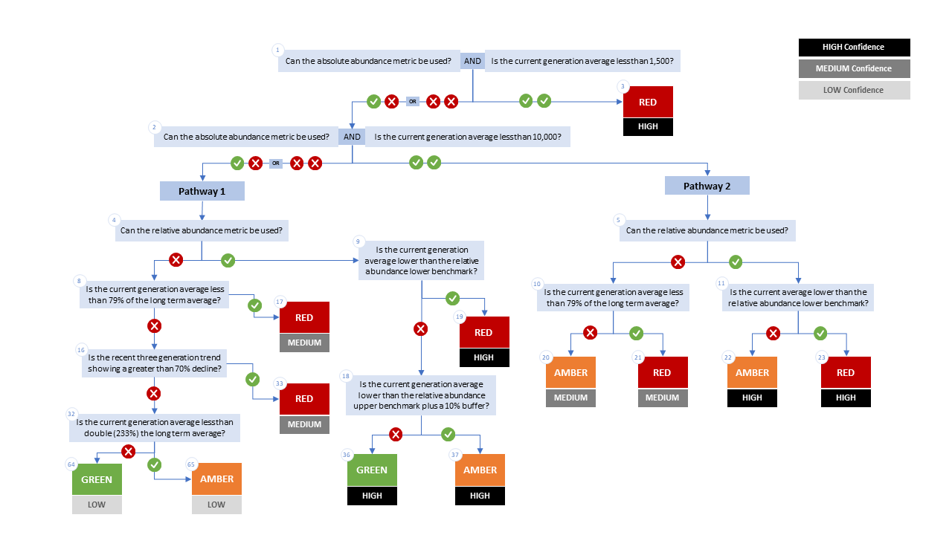

Figure A1. WSP rapid status decision tree (Table 2 includes written descriptions). To assess a CU, metric values are compared to thresholds presented at each decision point. Yes or No answers split each path of the decision tree, terminating at WSP rapid status assignments. The different splits are identified as nodes: 1 to 65. Pathway 1 is taken when the CU has no absolute abundance data, or these data exist, but fall above its upper threshold of 10,000. Pathway 2 is taken when the CU has absolute abundance data and these fall under its upper benchmark of 10,000.

Appendix B: Meeting History and Participants
Tables and summaries of meetings and participants, specifically participants who identified as a subject matter expert for one or more CUs.
Table B1. Meeting participants for the review of the 2022/23 Wild Salmon Policy Rapid Status Scanner for Fraser Pink, Chum and Sockeye. Meeting took place on January 8, 2025.
Kaitlyn Dionne | Fraser and Interior Stock Assessment, DFO
Michael Arbeider | Fraser and Interior Stock Assessment, DFO
Chuck Parken | Fraser and Interior Stock Assessment, DFO
Colin Bailey | Fraser and Interior Stock Assessment, DFO
Sue Grant | Science, DFO
Isabella Borea | Fraser and Interior Stock Assessment, DFO
Marissa Glavas | Fraser and Interior Stock Assessment, DFO
Scott Decker | Fraser and Interior Stock Assessment, DFO
Matthew Townsend | Fraser and Interior Stock Assessment, DFO
Kelsey Campbell | Upper Fraser Fisheries Commission
Pete Nicklin | Tsilqotin National Government
Elinor McGrath | Okanagan Nation Alliance
Chad Fuller | Okanagan Nation Alliance
Michelle Walsh | Secwepmec Fisheries Commission
Maxine Bruce | Lil’wat First Nation

Consensus: general agreement of group as a whole, or absence of evidence-based opposition to conclusions. Determined by the “weight of evidence” (scientific data, information, and analysis ) where multiple results are reported. In the event of disagreements, equally plausible conclusions can be reported. Dissenting views must be clearly described in the narrative.

